
THE G8 EXAMINATION
Kenya Certificate of Secondary Education
FORM 4 TERM 2- JUNE 2026

232/2
PHYSICS PAPER 2
MARKING SCHEME PHYSICS
✓2
- angle =180-(90+20)= 70º
- (a) Long sightedness
✓1
(b) Introducing a concave lens
✓1
- The plain sheet of paper absorbs some light while the mirror doesn’t. it reflects all the light.
✓1
- Rectilinear propagation of light.
✓1
- $m=2$
$2=\frac{v}{u }→v=2u$
✓1
$$u=15 cm$$
$$v=-30 cm since the image is upright$$
$\frac{1}{f}=\frac{1}{u}+\frac{1}{v}$
$\frac{1}{f}=\frac{1}{15}-\frac{1}{30}$
✓1
$\frac{1}{f}=\frac{2-1}{30}=\frac{1}{30}$
$f=30cm$
✓1
✓1
✓1
✓1
- Has a higher emf per cell than nickel-iron accumulator.
- $P=VI$
$$40=240I$$
$$I=\frac{1}{6}A$$
$$R=\frac{V}{I}=\frac{240}{\frac{1}{6}}$$
$$R=1440Ω$$
- Prevents the risk of electric shock in case of faulty connection of electrical current.
✓1
- The positively charged rod attracts the negatives and “repels” the positives.
✓1
When earthed, electrons flow from the earth and neutralize the positive charges.
✓1
The electroscope acquires negative charge.
✓1
- - The angle at which the conductor cuts the magnetic field.
✓1 for one correct
- The length of the conduct

Type of radiation | Detector | Use  ✓$any correct$
Microwave | Crystal detector, solid state diodes | - Radar  - point to point communication links  - wireless networks  - remote sensing
Infra red  ✓1 | Thermopile, blackened bulb thermometer | Warmth sensation

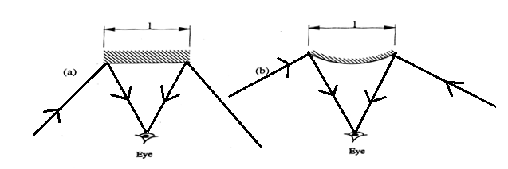

- The negative charges induce positive charges on water by repelling the negative charges. This causes the stream to be attracted towards the rod
✓1
✓1

SECTION B (55 MARKS)
13.a) Distinguish between transverse waves and longitudinal waves. (2 marks)
Transverse waves are waves in which the vibration of particles is perpendicular to the direction in which the wave travel.  While longitudinal waves are waves in which the vibration of particles is parallel to the direction in which the wave travel. 

b) Plane water waves travels from a deep end into a shallow end in a swimming pool at a
velocity of 4m/s. If the wavelength of these waves in deep end is 6cm and in the shallow end
is 1.5cm, determine the velocity of these waves in the shallow end. (3 marks)

V1/V2 = λ1/λ2 

V2 = (4m/s x 0.015m)/(0.06m) 

= 1m/s 

c) State one factor that affects the velocity of sound in a solid. (1 mark)
-the temperature  one mark for any correct answer
- the density of the solid. 
d) A disc siren with 200 holes is rotated at constant speed making 0.5 revolutions per second. If
air is blown towards the holes, calculate:
i) The frequency of sound produced. (3 marks)
Frequency = no. of revolutions x no. of holes 
=0.5 x 200 
= 100Hz 
ii) The wavelength of the sound produced if velocity of sound in air is 340ms-1 (3 marks)
V=fλ 
λ = 340/100 
= 3.4m 
e). State one way of reducing echoes in a room? (1mark)
-by covering seats, walls, the floor and the ceiling with soft sound absorbing materials. 
14. (a)  - Large currents can be drawn from them over a short period of time.  - They require very little attention to maintain.  - They are lighter (more portable) than the Lead – acid accumulators.  - They can be kept in a discharged condition for a very long time before the cells are ruined | √ 1mark- any one
b)  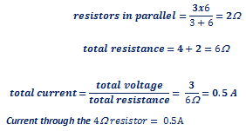 | √ 1mark –Total resistance  √ 1mark-Subst. for I=V/R  √ 1mark- Correct ans.
c(i)  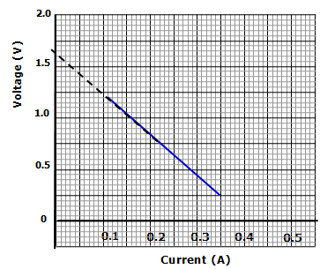 1.65V | √ 1mark- correct value of e.m.f $±0.05$  (Allow value indicated on the extrapolated graph)
ii) E = V + Ir  V= -Ir +E  -r = slope  $$Slope = \frac{change in voltage}{change in current}=\frac{0.4-1.5}{0.31-0.03}=\frac{-1.1}{0.28}= -3.93$$  -r=$-3.93$  Internal resistance = $3.93$ | √ √ 2marks-slope  √ 1mark- relating slope with r and correct value
ii 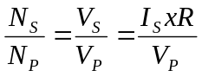 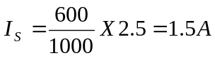 | √ 1mark- formula &/or  √ 1mark -Correct subst.  √ 1mark- Correct ans. with unit
15. a)(i) Cathode rays are streams of electrons emitted from the surface of a metal by thermionic emission
ii) They travel in straight lines
(Other property) They cause fluorescent surfaces to glow
(b) i) Intensity of radiation
ii) Energy of radiation
iii) Type of metal
(c) a) A. Cooling fins H. Cathode
b) Tungsten or molybdenum has high melting point to withstand high temperatures.
c) To ensure efficient dissipation of heat.
d) To absorb the stray x-ray radiations which would otherwise affect the x ray tube operators
e) To prevent electrons from losing energy due to collisions with air molecules and ionization.
f) The temperature of the cathode increases. This increases the number of electrons released hence the intensity of x-rays.

17.  a) to earth the device and prevent electrocution  b) lighting circuit draws a smaller current than cooker circuit  c) I 20v  ii 1.5 A  III 30A | -
18 a)  - Capacitor stores electric charge while cell as a device to convert chemical energy to electrical energy.  - Capacitor is passive component of circuit while cell is an active component of circuit.  - Capacitor discharges instantly while cell runs for longer time.  b)  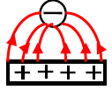  c) (i) P.d increases.  (ii) Charge remains unchanged.  (iii) Capacitance decreases.  d) 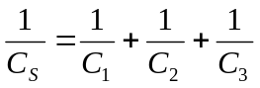 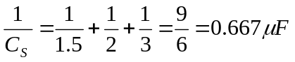  e) i)Milliameter reading which is initially high gradually reduces to zero.  ii) Voltmeter reading increases from zero to maximum value (4.5V).  iii) .  - Negative charges flow from negative terminal of the battery to the plate connected to it.  - At the same rate, negative charges flow from the other plate of the capacitor towards the positive terminal of the battery.  - Equal positive and negative charges appear on the plates.  - A potential difference is therefore set on the plates. | √ 1mark- Any one  √ 1mark- (Direction tied to shape of the field lines)  √ 1mark-  √ 1mark-  √ 1mark-  √ 1mark-Capacitance √ 1mark -Correct subst. Q=CV  √ 1mark- Correct ans.  √ 1mark –  √ 1mark –  √ 1mark  √ 1mark
c)  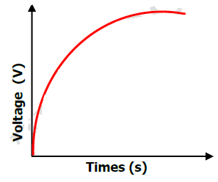 | √ 1mark- Smooth curve flattening for max. voltage

